-- SM_VHDL.VHD (VHDL)

-- This code produces a Moore state machine with output Z = Q[1]

-- James Liu

-- ECE2031 L10

-- 10/03/2013

LIBRARY IEEE;

USE IEEE.STD_LOGIC_1164.All;

ENTITY SM_VHDL IS -- Do not modify this entity statement!

PORT(X : IN STD_LOGIC_VECTOR(1 DOWNTO 0);

RESETN,

CLOCK : IN STD_LOGIC;

Z : OUT STD_LOGIC;

Q : OUT STD_LOGIC_VECTOR(1 DOWNTO 0) );

END SM_VHDL; -- Do not modify this entity statement!

ARCHITECTURE behavior of SM_VHDL IS

TYPE STATE_TYPE IS (A, B, C); -- Define SM states

SIGNAL state : STATE_TYPE; -- Establish SM’s current state

BEGIN

PROCESS(CLOCK, RESETN) -- Trigger on clock and reset input

BEGIN

IF RESETN = '0' THEN -- Reset state to A on reset trigger

state <= A;

ELSIF CLOCK'EVENT AND CLOCK = '1' THEN

CASE state IS

WHEN A =>

CASE X IS -- State is dependent on X and Q

WHEN "00" => state <= B;

WHEN "01" => state <= A;

WHEN "10" => state <= C;

WHEN "11" => state <= A;

END CASE;

WHEN B =>

CASE X IS

WHEN "00" => state <= B;

WHEN "01" => state <= B;

WHEN "10" => state <= C;

WHEN "11" => state <= A;

END CASE;

WHEN C =>

CASE X IS

WHEN "00" => state <= B;

WHEN "01" => state <= A;

WHEN "10" => state <= C;

WHEN "11" => state <= C;

END CASE;

END CASE;

END IF;

END PROCESS;

Z <= '1' WHEN state = C ELSE '0';

Q <= "00" WHEN state = A ELSE "01" WHEN state = B ELSE "10";

END behavior;

**Figure 1.** VHDL code for a Moore state machine with output Z = Q1.

**Figure 2.** Functional simulation waveform diagram, that tests the a Moore state machine with output Z = Q1 on all state transitions, compared to a known-good result.

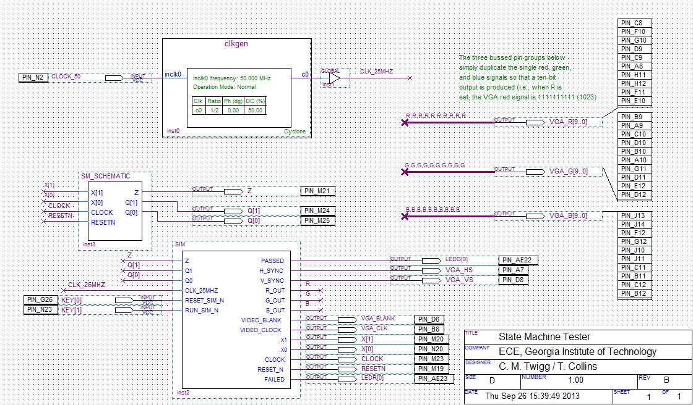

**Figure 3.** Schematic of a state machine tester meant to test a 3 state Moore state machine with Z = Q1.

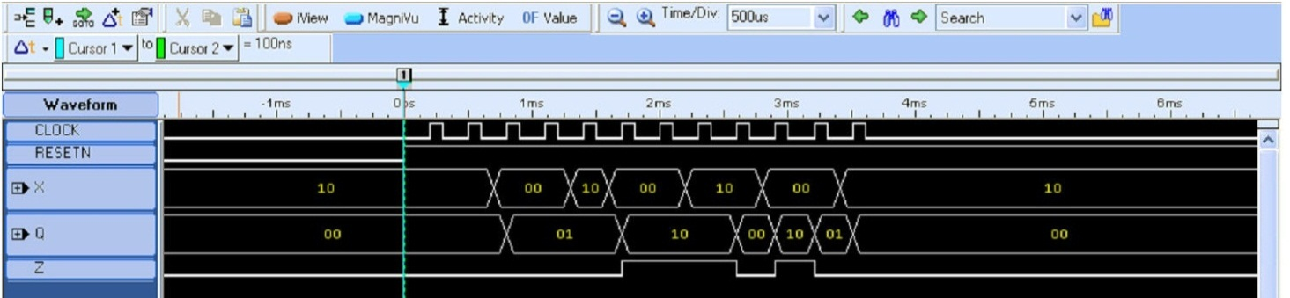

**Figure 4.** Logic analyzer screen capture of the state machine tester output waveform during a test of a 3 state Moore state machine with Z = Q1.

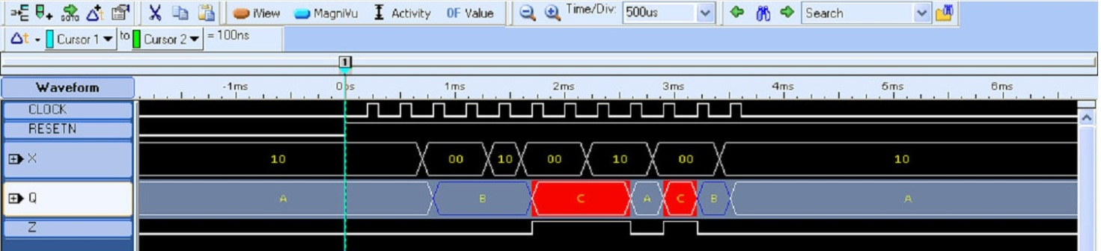

**Figure 5.** Logic analyzer screen capture of a state machine tester output waveform during a test of a 3 state Moore machine with Z = Q1. The radix for the state (Q) has been changed from binary to symbolic to more easily show the state of the Moore machine at any given point in time.